RT SCHOOL LOGO
Pupil Premium Strategy Statement
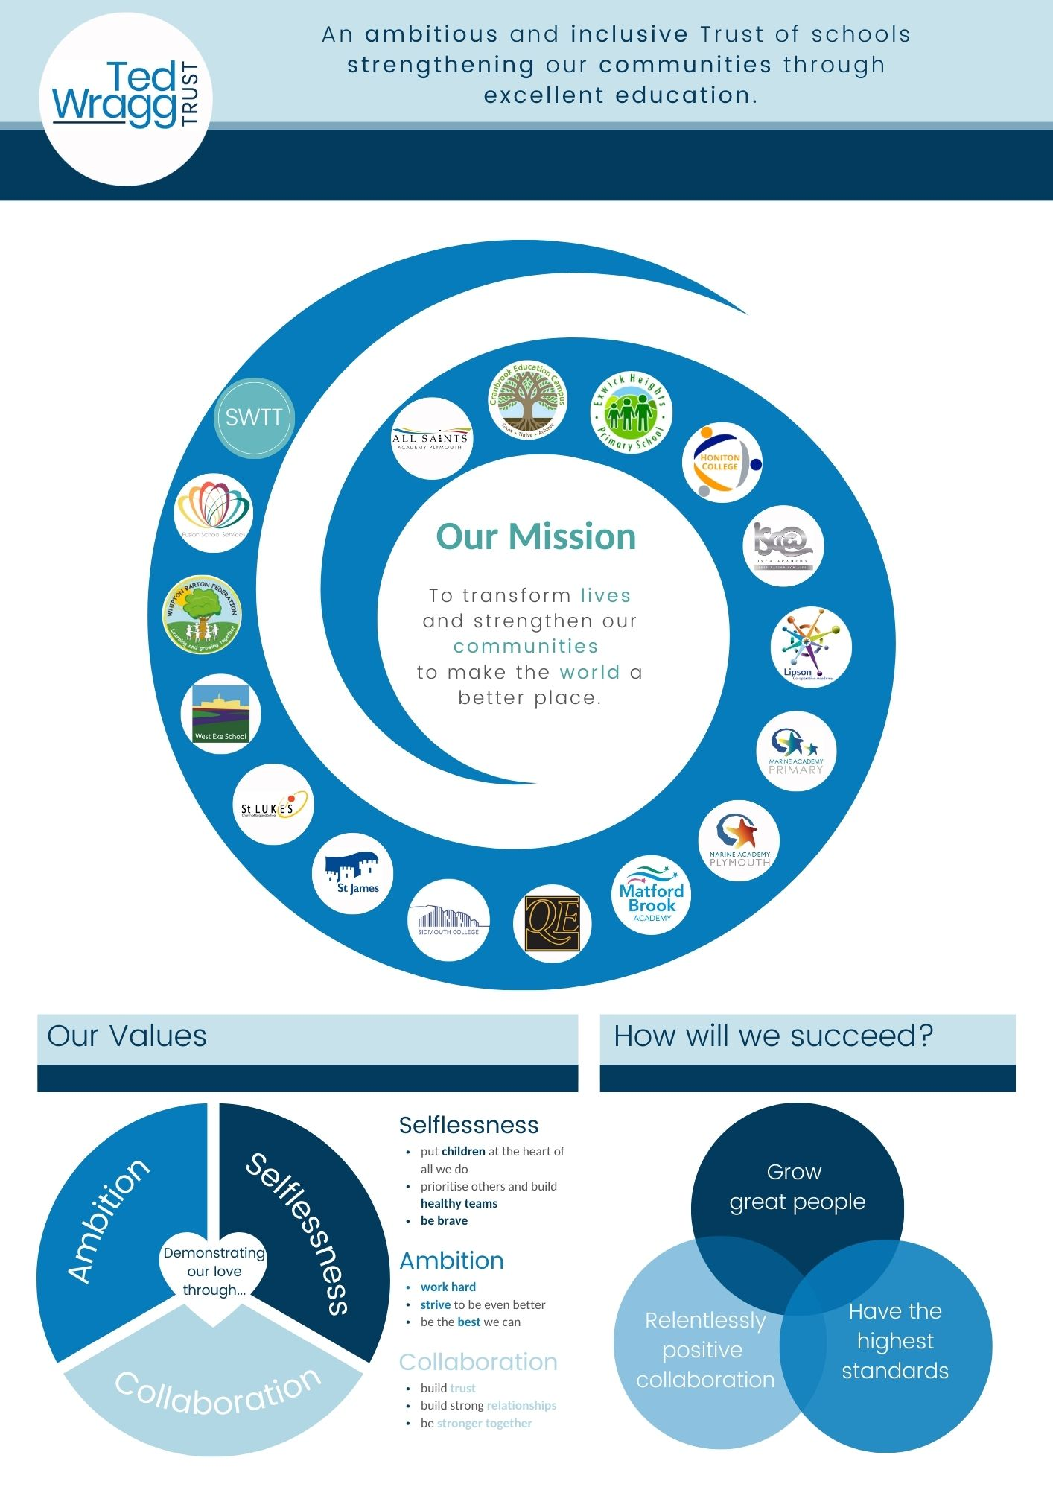
This statement details our school’s use of pupil premium (and recovery premium for the 2023 to 2024 academic year) funding to help improve the attainment of our disadvantaged pupils. It outlines our Pupil Premium Strategy, how we intend to spend the funding in this academic year and the effect that last year’s spending of pupil premium had within our school.

School Overview
Detail | Data
School name | Honiton Community College
Number of pupils in school | 755
Proportion (%) of pupil premium eligible pupils | 201 (27%)
Academic year/years that our current pupil premium strategy plan covers. | 2024-2027
Date this statement was published | 31st December 2023
Date on which it will be reviewed | 1st November 2024
Statement authorised by | Alex Kirkbride
Pupil premium lead | David Dagger
Governor / Trustee lead | Chris Meek
Funding Overview
Detail | Amount
Pupil premium funding allocation this academic year | £164,565
Recovery premium funding allocation this academic year | £44,988
Pupil premium funding carried forward from previous years (enter £0 if not applicable) | £0
Total budget for this academic year  If your school is an academy in a trust that pools this funding, state the amount available to your school this academic year | £209,583

Part A: Pupil Premium Strategy Plan
Statement of Intent
Our intention is that all pupils, irrespective of their background or the challenges they face, make good progress and achieve high attainment across the curriculum. We have considered the challenges faced by vulnerable pupils and the activity we have outlined in this statement is planned to privilege our disadvantaged cohort. This will support their needs and those of our wider vulnerable group, regardless of whether they are disadvantaged or not.

Knowing our children as individuals is vital and key to our Disadvantaged Student Strategy. We work closely with our local primary schools and use a range of diagnostic testing to identify both the challenges and gaps in learning. Our curriculum is the heart of our school and is the key driver to ensuring success and equity of opportunity for all of our children. The curriculum has been developed to clearly outline the essential knowledge that all students should learn and we effectively use assessment to make sure we know what has and hasn’t been learnt. Through high quality teaching and learning, and carefully targeted intervention we support all students to make good progress.
Learning does not happen unless students are safe and secure, have positive, trusting relationships with adults around them and perceive these adults as being fair. Ensuring students have the emotional security to learn effectively will always come first in our school and our exceptional pastoral care provides the environment for all students to achieve.

Challenges
This details the key challenges to achievement that we have identified among our disadvantaged pupils.

Challenge Number | Detail of Challenge
1 | Our disadvantaged students have lower attainment and progress scores than their non-disadvantaged peers. Progress 8 score is -0.16 for disadvantaged students, compared with 0.10 for whole school. Attainment 8 for disadvantaged students is 37.34 compared with 46.31 for whole school. The percentage of disadvantaged students achieving a grade 5+ in English and Maths is 17% compared with 38% for the whole school.
2 | Teaching of our disadvantaged students is sometimes not adapted for their individual needs.
3 | Our disadvantaged student’s attendance rates are lower than their non-disadvantaged peers.
4 | Disadvantaged students need to have a higher profile in the school.
5 | Our disadvantaged students sitting exams require more support.
6 | Disadvantaged students leaving our school need to be well prepared to take their next step. The percentage of disadvantaged students staying in education or entering employment after GCSEs is 92% compared with 95% for the whole school.
7 | We need to be aware of the individual challenges faced by our disadvantaged students.
8 | We need to address the individual challenges faced by our disadvantaged students.

Intended Outcomes
This explains the outcomes we are aiming for by the end of our current strategy plan, and how we will measure whether they have been achieved.
Intended Outcome | Success Criteria
Leaders and teachers have a good understanding regarding current best DS practice | Leaders and teachers at HCC are employing strategies that have a proven track record of impact on disadvantaged students. Decisions regarding DS strategy are well informed, evidenced and contextualised.
Improve the quality of teaching for our disadvantaged students | Teachers and leaders are aware of their disadvantaged students’ individual needs and implement appropriate support.
Improve the quality of learning for our disadvantaged students | Or disadvantaged students have access to online learning platforms. Reflection room referrals reduce for our disadvantaged students. Disadvantaged students have the educational resources they require to succeed.
Improve the co-ordination of key staff that impact our disadvantaged students | DS lead will engage with: Transition Lead. Heads of Year. Subject Leads. Behaviour and Inclusions. PD Lead. SENDCo. This will assist both establishing individual needs and implementing appropriate support.
Improve the cultural capital of our disadvantaged students | 25% of students engaged in all enrichment activities are disadvantaged. Disadvantaged students are prioritised for ‘next steps’ guidance and advice.
Improve the attendance of our disadvantaged students | Attendance of our disadvantaged students matches that of their non-disadvantaged peers.
Disadvantaged students have a higher profile and priority in the school | DS lead conducts assemblies, staff briefings and attends relevant meetings to raise the profile of our disadvantaged students and ensures they are considered in all the decisions we take.

Activity in this Academic Year
This details how we intend to spend our pupil premium (and recovery premium funding) this academic year to address the challenges listed above.
Teaching
Budgeted cost: £104,791
Activity | Evidence that supports this approach | Challenge number(s) addressed
Coaching programme/Steplab | Coaching will improve the quality of teaching for all students in an incremental way, this will inevitably improve the teaching of disadvantaged students as well. We have an explicit coaching strand that outlines how teachers can improve the learning experience of their DS students.  https://assets.publishing.service.gov.uk/government/uploads/system/uploads/attachment_data/file/473974/DFE-RR411_Supporting_the_attainment_of_disadvantaged_pupils.pdf  https://educationendowmentfoundation.org.uk/projects-and-evaluation/projects/iris-connect  https://educationendowmentfoundation.org.uk/guidance-for-teachers/using-pupil-premium  https://samsims.education/2019/02/19/247/ | 1/2/5/7/8
Homework | Our disadvantaged students often struggle with homework because of socio-economic challenges at home. The homework programme will be accessible to all and all resources provided to maximise their chances of completing homework.  https://educationendowmentfoundation.org.uk/guidance-for-teachers/using-pupil-premium  https://assets.publishing.service.gov.uk/government/uploads/system/uploads/attachment_data/file/963625/Research_for_EIF_framework_updated_references_22_Feb_2021.pdf | 1/2/5
Disruption free classrooms | It is important that our disadvantaged students have the best possible learning experience while in school and this will go some way to facilitate this. Any students that are sent to the reflection room will only miss the lesson they have been sent from and it will not have a knock-on effect to subsequent lessons. Our disadvantaged students are disproportionately represented in the reflection room.  https://educationendowmentfoundation.org.uk/guidance-for-teachers/using-pupil-premium | 1/2/3/8

Targeted academic support
Budgeted cost: £52,395
Activity | Evidence that supports this approach | Challenge number(s) addressed
Devices for home use | Our students from challenging socio-economic backgrounds often don’t have access to IT devices beyond their phones and there is an increasing reliance on IT to deliver certain subjects.  https://d2tic4wvo1iusb.cloudfront.net/production/documents/pages/Protocol-review-of-socioeconomic-disadvantage-and-the-attainment-gap.pdf?v=1700395449  https://d2tic4wvo1iusb.cloudfront.net/production/documents/guidance/Remote_Learning_Rapid_Evidence_Assessment.pdf?v=1700391262  https://www.suttontrust.com/our-research/remote-learning-the-digital-divide/ | 1/2/3/6/8
Wifi dongles for home internet access | Our students from challenging socio-economic backgrounds often don’t have access to the internet and this is becoming increasingly important because of online learning platforms and revision materials.  https://www.suttontrust.com/our-research/remote-learning-the-digital-divide/  https://d2tic4wvo1iusb.cloudfront.net/production/documents/pages/Protocol-review-of-socioeconomic-disadvantage-and-the-attainment-gap.pdf?v=1700395449  https://d2tic4wvo1iusb.cloudfront.net/production/documents/guidance/Remote_Learning_Rapid_Evidence_Assessment.pdf?v=1700391262 | 1/2/3/6/8
Revision guide packs for Maths, English and Science | Our students from challenging socio-economic backgrounds often don’t have access to externally published revision materials and this can be a significant expense for their parents when studying nine or ten GCSEs or three or four A Levels.  https://d2tic4wvo1iusb.cloudfront.net/production/documents/pages/Protocol-review-of-socioeconomic-disadvantage-and-the-attainment-gap.pdf?v=1700395449 | 1/2/5/6/8
Literacy intervention and guided reading | Our disadvantaged students often join us in Y7 with lower-than-average reading ages and this persists as an issue until they leave.  https://educationendowmentfoundation.org.uk/education-evidence/teaching-learning-toolkit/reading-comprehension-strategies | 1/2/5/6
Mental Health Coach | Many of our disadvantaged students suffer from mental health issues and this increases their level of disadvantage and occasionally causes it.  https://educationendowmentfoundation.org.uk/education-evidence/teaching-learning-toolkit/mentoring | 1/3/5/6/7/8

Wider strategies
Budgeted cost: £52,395
Activity | Evidence that supports this approach | Challenge number(s) addressed
Educational Welfare Officer | Absence among our disadvantaged students is an ongoing issue. We have also seen a minor but worrying increase in those requesting to be educated from home.  https://educationendowmentfoundation.org.uk/educationevidence/teaching-learning-toolkit/parental-engagement  https://educationendowmentfoundation.org.uk/education-evidence/teaching-learning-toolkit/parental-engagement | 1/3/6/7/8
Persistently absent students | Persistent absence among our disadvantaged students is an issue and we have appointed a part time member of staff to address this.  https://www.supportservicesforeducation.co.uk/Page/20029  https://educationendowmentfoundation.org.uk/education-evidence/teaching-learning-toolkit/parental-engagement | 1/3/6/7/8
Laptops for reflection room | Our disadvantaged students have equal digital access while removed from classes.  https://d2tic4wvo1iusb.cloudfront.net/production/documents/pages/Protocol-review-of-socioeconomic-disadvantage-and-the-attainment-gap.pdf?v=1700395449 | 1/2/5/6
Headphones for low ability maths groups | Our disadvantaged students often don’t have their own headphones to access Sparx Maths.  https://d2tic4wvo1iusb.cloudfront.net/production/documents/pages/Protocol-review-of-socioeconomic-disadvantage-and-the-attainment-gap.pdf?v=1700395449 | 1/2/5/6
Homework Club | Students who not have a quiet place to study or the resources to study effectively are provided with these in HW club.  https://educationendowmentfoundation.org.uk/education-evidence/teaching-learning-toolkit/homework | 1/2/3/5/8
Next steps advice | Our disadvantaged students are prioritised for careers appointments and given advice when taking their options in year 9.  https://d2tic4wvo1iusb.cloudfront.net/documents/guidance/Careers_Education_summary_infograph.pdf | 2/7/8
‘All about me’ interviews | Teachers and leaders at HCC need to be aware of the individual challenges faced by our DS students.  https://d2tic4wvo1iusb.cloudfront.net/production/documents/pages/Protocol-review-of-socioeconomic-disadvantage-and-the-attainment-gap.pdf?v=1700395449 | 2/4/5/6/7/8
DS lead to raise the profile of our disadvantaged students’ students | Disadvantaged students at HCC do not have the same priority or profile as other vulnerable groups within the school  https://d2tic4wvo1iusb.cloudfront.net/production/documents/pages/Protocol-review-of-socioeconomic-disadvantage-and-the-attainment-gap.pdf?v=1700395449 | 2/4/7/8
Provision of uniform for | Many of our disadvantaged students are from socio-economically challenging backgrounds and their parents lack the funds to provide them with or replace school uniform.  https://d2tic4wvo1iusb.cloudfront.net/production/documents/pages/Protocol-review-of-socioeconomic-disadvantage-and-the-attainment-gap.pdf?v=1700395449 | 3/8

Total budgeted cost: £209,583

Part B: Review of Outcomes in the Previous Academic Year
Pupil Premium Strategy Outcomes

Outcomes for disadvantaged pupils
To help us gauge the performance of our disadvantaged pupils we compared their progress 8 and attainment 8 scores for EBacc, English, Maths and open subjects in 2022/23, to those for disadvantaged and non-disadvantaged pupils at national and local level (though these comparisons are to be considered with caution given ongoing pandemic impacts) and to results achieved by our non-disadvantaged pupils.
The data demonstrates that on all measures our disadvantaged students were significantly below national average, and performed less well that their non-disadvantaged peers. The performance of disadvantaged students did however improve on 2021/22 data.
We have also drawn on school data and observations to assess wider issues impacting disadvantaged pupils' performance, including attendance, behaviour and wellbeing.
The data demonstrated that our disadvantaged students are more likely to be absent, sent to the reflection room, receive more concern points and that 22% of our disadvantaged students were also SEND,
Based on all the information above, the performance of our disadvantaged pupils did not meet expectations, and we are at present not on course to achieve the outcomes we set out to achieve by 2024/25, as stated in the Intended Outcomes section below.
Our evaluation of the approaches delivered last academic year (detailed below) indicates that although almost all of the strategies we implemented were concluded successfully, a huge amount of work went into it and we improved outcomes for our disadvantaged students, we still have a long way to go. We have reviewed our strategy plan and made changes to how we intend to use some of our budget this academic year. Part A of this document above provides more details about our planning, implementation, and evaluation processes that we will employ in the coming academic year.

This details the impact that our Pupil Premium activity had on pupils in the 2022 to 2023 academic year.

Intended Outcome | Success Criteria | 21-22 | 22-23 | 23-24
DEAR re-launch using set books for Year 7&8 supported by AR info and quizzing. | The book sets purchased will include BAME authors to ensure a diverse menu for tutor reading. Celebrate reading, male role models promoted.
 | Students are exposed to a greater number of words and challenging texts. The teacher ensures correct pronunciation and leads on the 30-minute daily reading programme. Students are developing a wider and more appropriate vocabulary range for subsequent use across the curriculum.
Purchase study guides as required. | All students can easily access resources at home and teachers can use them to support homework and distance learning.
Purchase pens for mini-whiteboards for all students 7-11, mini-whiteboard and pens purchased for all Post 16 students. | To support AfL strategies without having to walk around the classroom.
DEAR extraction group in each year group to read together - book sets purchased. | Students with LRA supported to improve their vocabulary and confidence to access full range of subjects.
Year 7 Literacy support, small group, 6-week intervention. | Short term intervention to boost Reading Age and curriculum accessibility.
Year 11 My Maths subscription. | ELT will quality-assure decisions for catch up tuition through conversations with HODs and cross-referencing data.
Year 11 students enrolled with My Tutor through the NTP – Period 6 sessions. | Students learning and revision supported - increase engagement in revision process (monitor students accessing and data collection info).
Intervention Teacher for targeted students across KS3 to Post-16 | Rapid progress over 10 lessons when comparing baseline assessment at entry and to overall results.
LSA Recruitment. | Working specifically with identified students to target areas of difficulty.
Quality First Teaching. | Training for WalkThru approach: https://www.walkthrus.co.uk/
Careers Support | Dedicated Careers interview and input for identified students.
Attachment Based Mentoring/Training | To support ‘Positive Behaviour Management’ across the College.  Books: ‘When the adults change everything changes’ and ‘Running the Room’.
Educational Psychology Service. | Bespoke input and advice for targeted students through Babcock Services.
Homework Club. | Supervised and supported forum for students to undertake homework.
EAL Software. | Online learning platform to support primarily with resources and translations.
Class set of laptops and headphones. | More access to IT in lesson time - bookable across the curriculum, for quizzing, extraction groups and for use at breaks and lunches. Increase in student confidence with technology and to build on good practice established during the lockdown.
Visualisers in all classrooms. | Minimise negative impact of teachers not being able to move around the room freely to give feedback or gather students for demos/modelling.
Class Charts roll-out to support setting of Distance Learning. | Supports monitoring for quality/ consistency and completion across all subjects and all students (particular focus on vulnerable students’ experience).

Success criteria met | On track to meet success criteria | Started but not on track to meet success criteria | Not yet started

Externally Provided Programmes
Please include the names of any non-DfE programmes that you purchased in the previous academic year. This will help the Department for Education identify which ones are popular in England
Programme | Provider
Coaching | Steplab
Maths | Sparx Maths
Enrichment | Absolute Education
Literacy | Lexia
Attendance, homework, parent comms. | Bromcom
Teaching and learning | Educake
Teaching and learning | Seneca learning

Service Pupil Premium Funding

Measure | Details

