Careers strategy
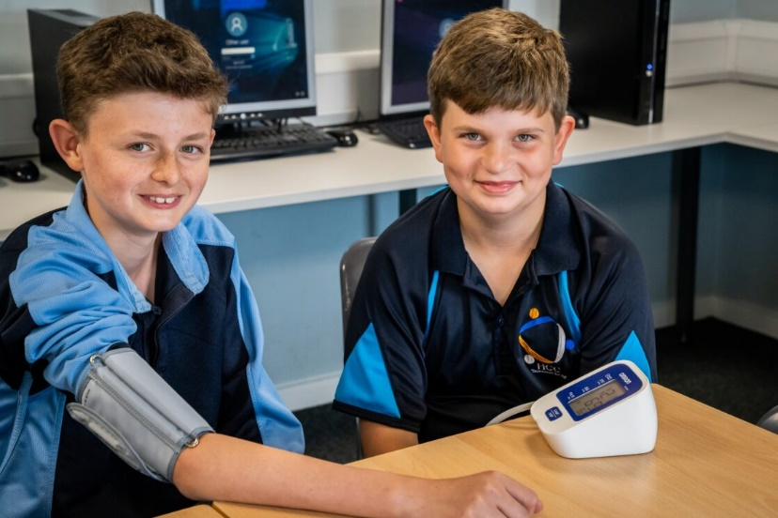
including Provider Access and Work Experience
February 2024

Hayley Blight – Lead for Personal Development and Careers Lead KS3/KS4
Selena Burroughs – Director of Post-16 and Careers Lead Post 16

Honiton Community College Careers Mission Statement
Honiton Community College will provide a holistic and engaging careers programme for students in Years 7 – 13 through curriculum content, careers guidance , assemblies, careers enrichment and personal development sessions. The careers programme will comply with the Bakers Clause and meet the Gatsby Benchmarks.

Provider Access Policy
This policy statement sets out the college’s arrangements for managing the access of providers to pupils at the college for the purpose of giving them information about the provider’s education or training offer. This complies with the college’s legal obligations under Section 42B of the Education Act 1997.

Student entitlement
All students in years 8-13 are entitled:
• to find out about technical education qualifications and apprenticeships opportunities, as part of a careers programme which provides information on the full range of education and training options available at each transition point;
• to hear from a range of local providers about the opportunities they offer, including technical education and apprenticeships – through options events, assemblies and group discussions and taster events;
• to understand how to make applications for the full range of academic and technical courses.
Whilst the statutory requirement is from Year 8 – 13, the colleges career programme will incorporate Year 7 in many of the opportunities above.

Process and Opportunities for accessing
A provider wishing to request access should contact Hayley Blight, Lead for Personal Development and Careers Lead for KS3/KS4 or Selena Burroughs, Director of Post-16 and Careers Lead for KS5.
Hayley.Blight@honiton.college Selena.Burroughs@honiton.college
The careers programme is delivered as part of our Personal Development curriculum. There are timetabled lessons from Y7 to Y11 as well as Personal Development sessions every other week which are delivered through the tutor program. Post-16 also follows a Personal Development Programme that includes a Post-16 careers programme. This as well as assembly time will offer providers opportunities to come into college to speak to students. In addition, we have Progress and Information Evenings that will offer providers opportunities to speak to pupils and/or their parents/carers.
Y10 have Work Experience in the Spring term. This has been timed to reduce competition with other schools of finding a suitable work placement.
Y12 have Work Experience in the summer term. This is proceeded and followed by a series of sessions focussed on the next steps and we welcome providers to attend these sessions.

Premises and Facilities
The college will make the main hall, classrooms, and careers meeting room, available for discussions between the provider and students, as appropriate to the activity. The college will also make available AV and other specialist equipment to support provider presentations. This will all be discussed and agreed in advance of the visit with the Careers Leads.
Providers are welcome to leave a copy of their prospectus or other relevant course literature at the Careers Resource Centre.

Careers opportunities at HCC
A variety of careers opportunities are provided at HCC that includes :
- Focussed themed assemblies
- Curriculum focussed workshops
- Curriculum focused trips to universities and schools/colleges
- Career drop-in sessions with a range of providers
- Individual CEIAG appointments
- Careers focus weeks
- Careers focused tutor sessions
- Opportunities for exploring careers options through our common curriculum.

Tracking of Careers Activities’

The Careers Tracker allows all activities from Year 7 – 13 to be recorded as well as ensuring we are meeting the Gatsby Benchmarks.
Absolute Education (AE) is used as our online platform for tracking Enrichment activities across years 7-13. Display Enrichments | Absolute Education (absolute-education.co.uk) It allows recording of all careers focused trips/visits and allows tracking the percentage of students who have taken part in a career focused activity in the current academic year. This can be presented as a percentage into DS, SEND, PP, FSM to direct intervention and boost numbers of engagement.

Professional Partnerships
Professional partnerships are continued to be developed with a range of employers and educational institutions. Links are developed by the Careers Fair and the establishing of Business Breakfasts. We have a broad and growing network of employer, Higher and Further Education and other training providers that engage with our students and careers curriculum.

Careers Education, Information, Advice and Guidance (CEIAG)
All students have at least one CEIAG individual meeting by the age of 16 and the opportunity for a further meeting by the age of 18. Our CEIAG appointments are completed with all of year 10 during the Summer Term with an external careers company, Future Smart Careers (FSC) with a qualified careers advisor. Students are also given the opportunity for another meeting in Year 11 if required.
Post 16 CEIAG meetings are conducted by the Director of Post 16 who is Level 6 qualified in Career Advice and Guidance.
We prioritise students who are at risk of NEET and year 9 students who are presenting with high profile behaviour concerns or are lacking motivation/direction. A log is kept of all appointments via an online shared platform and this log is shared with students via college Email. Our FSC advisor also keeps a log of potential destinations which identifies any potential NEET students.

NEET
Three review points are on the strategic calendar throughout the academic year where the careers leads and Head of Year 11 review and action any potential NEET students using the shared log from the FSC CEIAG appointments.

Work experience

Year 10
Year 10 Work Experience is completed in the summer term for a period of 5 days. Careers South West (CSW), provide students access to a database of potential employers and complete the required placement checks. Support sessions are offered to all students both within personal development lessons and drop in sessions. Where face to face work experience is not available or appropriate, an online platform is used and students are supervised in college for the week completing the programme. The college has a work experience contract with Career South West to provide Health and Safety checks on placements.

Year 12
Year 12 Work Experience is completed at the end of the summer term for a minimum of 3 days. Students would have studied careers pathways Post 18 as part of their personal development curriculum before deciding and securing their placement to complement their next steps.
Careers Lead for Post 16 ensures all required checks are performed for Post 16 placements and communication with parents/ carers and employers. Individual checks are performed with all students on placement via telephone call if outside of reasonable travelling distance or in person. Review meetings with a report from the employer is held with the student and Director of Post 16 after the placement is complete. Where face to face work experience is not available or appropriate, an online platform is used and students are supervised in college for the week completing the programme.

Students from Year 10 or 12 wishing to complete their work placement outside of the published dates will be considered on an individual basis by the Head of Year and Career Leads.

Careers in the curriculum

Booklets
The common curriculum booklets at KS3 provide opportunities for careers to be considered and discussed across a range of subject areas through the use of the career’s icon (see below) as well as the careers focused independent learning lessons (see below). All years 7-13 will have Personal Development lessons as part of their timetable. Careers and next steps are a core theme running throughout the cycles of work (see below).
(Careers Icon used across common curriculum)

(Example of a careers focussed independent learning lesson from year 7 cycle 1 – biomes, Geography)

(Personal Development 5-year learning journey)

Careers Focus week
Careers focus weeks are scheduled 3 times per academic year. This includes assemblies with a focus on next steps, careers, university, colleges, apprenticeships, as well as a Friday Personal Development session delivered by tutors focusing on careers. The Future Smart Careers advisor provides lunchtime drop-ins for all year groups. The aim of careers focus week is to highlight the importance of careers and to encourage all of the students to start thinking of next steps in order to choose appropriate GCSE options and have an understanding of grades needed for their intended destinations.

Compass Plus and linked Governors
Compass Plus reviews are held 3 times per year in conjunction with the colleges appointed Devon, Plymouth and Torbay Careers Hub Careers Enterprise Coordinator. The reviews are shared with the Principal and the rest of the Senior Leadership Team as well as the Governing Body. The also feed into The Ted Wragg Trust Careers review.
The College has an appointed Careers link governor who meets with the careers leads 3 times per year.

Gatsby benchmarks
The college regularly ensures compliance with the Gatsby benchmarks via the Compass Plus reviews. Any non compliance is actioned by the careers leads.

Devon Plymouth and Torbay Careers Hub.
The college is a member of the Devon, Plymouth and Torbay Careers Hub with the careers leads from the college regularly attending network meetings and the annual conference.

